# Aycada Simulation Game for Production and Capacity Management

## **Examination: Decision Paper of the Product Manager 1**

**Name**: Zeena

**Surname**: Jaber

**Group (D1, D2, D3 or BWL/Block):** English Track 1 (CBA)

**Companies (C1, C2, ... C11):** C10

## **Situation**

The Executive Board makes monthly decisions on

* The planned production volumes for the four products offered by the company [PU/month] and
* The planned production capacity for the four production stages [hours/month].

Each month, the Executive Board as a body must therefore make eight individual decisions. The first decision is made for month 36.

Each board member has the task of creating a decision template, which serves in particular to support the first joint board decision for month 36. This paper answers the following questions:

## **Questions**

### **Is it economically advantageous to offer the product?** **(2 points)**

Yes. Because the sales price per unit is € 6.08 (according to variable costing statement of month 36, this is unlikely to change due to the fact that the prices are set but the Aritir Drug Association) and the Full total cost per PU is € 5.05, the profit per PU is € 1.03. Moreover, the profit margin as a % of price/unit is 16.9%. Moreover, for month 36, the contribution margin per unit was €5.14. This means that for every unit sold, €5.14 are contributed towards covering fixed costs. The total margin for the month was €1,003,325 which is encouraging and implies the product is economically advantageous. The cumulated margin at the end of month 36 was €32,855,496 meaning that on average, the product provides around €1,095,183.20 towards covering fixed costs every month, this further reinforces the fact that it’s economically advantageous.

It can be observed that demand is more or less constant during the period which allows Aycada to hold the necessary inventory for a cheap(er) amount of €0.15/PU, avoid backlogging costs (of €0.28/PU) and fulfil every order. It gives a steady stream of income and proves its economic benefit

Sales Revenue – Full costs = Profit per unit

6.08 – 5.05 = €1.03

Cumulated contribution margin / number of months = average contribution margin per month

32,855,496/30 = €1,095,183.20

### **Are there time-dependent patterns in past demand (measured in packaging units of the product)? (2 points)**

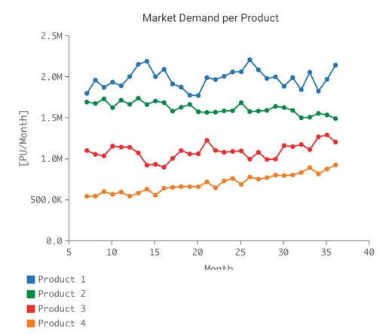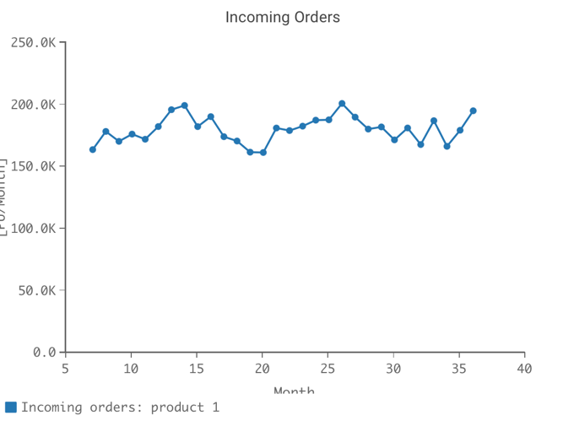

Yes, there are time-dependent patters where you can see a peak of around 200,000 and a trough of around 160,000 every 12 months. Overall, demand varies between 150,000 and 200,000 with a peak in month 26 at 200,973 and a trough at 161,408 in month 20. This trend is also seen at a larger scale in the Market Demand whereby the demand varies between 1.8M and 2.1M, with a peak in 2,210,703 in month 26 and a trough in month 20 at 1,775,488. Despite having no distinctly identifiable pattern, fluctuations are common and it’s evident that there is a seasonal cycle.

### **Which forecasting technique is best suited to provide the most accurate prediction of demand for the product?**

### **(2 points)**



For a more accurate representation of the data, I recommend using the exponential & seasonal forecast (using Excel) as the trend is similar to the previous data, as oppose to the linear forecast which isn’t so representative, showing that demand is more or less steady when in fact fluctuations are more common than not. The Exponential Smoothing forecast takes into account seasonal fluctuation from past data and uses that data to predict future values, keeping in account the seasonal cycles – the linear forecast doesn’t provide the same analysis.

### **How high will the demand be in the month (measured in packing units) in which the production quantity to be determined now is available to be delivered? (Note: To answer this question, use the forecast technique recommended above.) (3 points)**

There exists a three-month delay between decision on planned quantity and the availability of desired deliveries. Using the linear model from the previous question and seeing the data prediction at month 39. According to the graph, the demand at month 39 will be 188,795 units.

### **What is the mean absolute deviation between the actual observed demand for the product and the forecast (both measured in packing units) for months 25 to 36 when the selected forecasting technique is applied? (2 points)**

### 

The mean absolute deviation between the forecast and the actual for months 25-36 is 9626. This number allows us to see the accuracy of the demand forecast, hence creating a leeway number that we can add onto predicted demand as a backup for any deviations from the demand forecast.

This number represents an average error of 5.3% in the demand forecast in comparison to the actual numbers. This number was found by diving the average number of incoming orders by the MAD.

### **What quantity of the product (measured in packing units) would you keep in inventory? (2 points)**

To answer this correctly, one must look at the inventory holding costs, backlog order costs and cancellations along with current backlog order and current inventory.

When comparing the backorder costs and inventory holding costs for the different products, it is clear that Product 1 has the lowest Backorder Costs (0.28 €/PU) and Inventory Holding Costs (0.15€/PU) than the other products like product 4. Upon inspection, it’s clear to see why product 1 is the product with the highest inventory, as not only is it cheaper in the short-term to hold inventories rather than to deal with backlog orders, it’s also better long-term as customer satisfaction is always high with regards to this product, as the inventory can always meet demand – this is also shown in the constant fill rate of 100% for product 1. However, for a demand of around 200,000 monthly, an inventory between 300,000-375,000 is too much and unnecessarily adds inventory holding costs. I would plan the inventory around the demand with a slight surplus, rather than the very generous surplus observed in the past data.

Starting month 36, I would start planning to produce according to the demand forecast & keep a minimum of 9626 and a maximum of 19252 always in inventory as a backup for deviation from the forecast or unforeseen issues like a machine breaking down. The number 19252 is the mean absolute deviation multiplied by 2 representing the average deviations from the forecast that could occur on a monthly basis. This will allow for a decrease in fixed costs of inventory holding, and almost always maintain the 100% fill rate without an increase in backlog costs, which are more significant. The reason I have doubled it is because it takes 3 months for planned production to be ready, and this will allow for 2 consecutive months or 2/3 months in a quarter to have supply ready in case of deviations. This will allow us to keep almost 11% in inventory, accounting for double the error.

Moreover, as you can see in the table above, the max change from month to month was 12%, and there was an instance where an absolute change of 11% happened 2 months in a row. Now, because we’re producing according to the demand forecast, we should be covered enough with one set of the mean absolute deviation of 9626, doubling it is just a precaution against needing it twice in the space of 2 months. Hence, we hold between 5% and almost 11% inventory always as a backup, and if an absolute deviation rate of around 11% happens again, we can be more or less prepared and minimize backlog orders as much as possible.

To reiterate, I would always keep a maximum of 19252 in inventory (excluding the production units necessary according to the demand forecast from month to month). This number achieves a balance between having enough inventory on hand and not having to deal with backlog orders too frequently.

### **What planned production quantity of the product you are responsible for do you propose for month 36? (1 point)**

~~~~

To answer this question, one must keep in mind the inventory and the WiP inventory. Because both levels are really high for Product 1 and will continue to be so until month 39, I suggest that we halt production for this product as otherwise, we will have too much inventory going forward and this will keep the inventory holding costs much too high, hence increasing the fixed costs. The work initially going towards Product 1 can then go towards Product 3 and 4 as their inventory is 0. This will keep total capacity high while also aiding in fixing the issues related to products 3 & 4. While this may impact the learning curve for product 1, it will help our company as a whole in decreasing backlog orders & cancellations and improve the synergy.

Doing this will also aid in decreasing the full costs per unit because allocation fixed costs for sales and admin as holding inventory costs falls under fixed costs, and hence full costs. While this isn’t a sustainable way of increasing the contribution margin, it will do so as variable costs per unit will be = 0 and sales prices will remain as is. To clarify, this will not be the decision we make for all the months, just until we reduce the existing inventory for P1 and increase that of P3 and P4.

Planned production quantity = 0

### **What quantity of the product (measured in packing units) will be in the production and quality control process (WIP – work in process) in month 37? (1 point)**

### 

### WIP inventory is inventory which is being produced and is in quarantine. This process takes 2 months as a whole. Finding the WIP inventory for month 37 is easily done by calculating the already given figures on the website for the released production quantities for the 2 months prior.

Released PQ – Month 35: 180,671 PU

Released PQ – Month 36: 178,288 PU

Total WiP inventory - Month 37: 358,959 PU

## **Evaluation criteria**

|  |  |  |  |
| --- | --- | --- | --- |
|  | Insufficient | Satisfactory | Very good |
| Correctness of the answer | Answer is grossly incorrect | Answer is partially incorrect | Answer is correct |
| Justification of the answer | No justification available, neither in text form nor as a calculation | Satisfactory justification | Clear and convincing justification of the answer, with calculation (if applicable) |
| Correctness of the data/information used | Incorrect data/information used | Partly correct, partly incorrect data/information used | Correct and appropriate data/information used |